worksheet 2: Data, Events, Input and User Interfaces
UFCF9M-30-2 Game Engine Programming
The aim of this worksheet is to introduce you to working with data assets, events and user interfaces in Unity. Completing this worksheet will teach you how to work with Unity data assets, use its Input Action system, and create dynamic User Interfaces (UI).
It is assumed that you have completed the core tasks in Worksheet 1: Unity, Game Objects, and Scripting, and will build upon those core tasks. you have some experience writing Object-Oriented code from Games in C++, working with both Unity and Unity Hub from Principles of 3D Environments last year, and working with GitHub / GitKraken from both modules.
In this worksheet you will make a series of prefabricated objects, functionality to add and remove items from the inventory, and a UI menu to allow a player to do this.
This worksheet has been designed to cover learning content from teaching weeks 6 to 8. As such, it is expected that you will complete this over a three-week period. Feel free to read ahead if you have completed core tasks and feel ready to progress before the next session/s.

Checklist
Below is a checklist of tasks for the worksheet. Feel free to use this in order to keep track of where you are.

Core Tasks
☐Item Prefab Assets
☐Item Prefab Instances

Extension tasks
☐Custom Item Assets
☐Custom Item Prefabs
☐Scriptable Object Items

Week #6: Data & Assets
In this week’s lecture content, we covered Data-Oriented Programming, the Asset Pipeline, and Game Engine Assets. This section of the worksheet will help you to set up prefabricated (prefab) assets for use in your project.

Creating Item Prefab Assets
If you have completed Worksheet #1, you should already have a generic game object representing an item for your inventory system. Let’s create a prefab for this object so that we can reuse it as a template for other objects in our scene. Start by creating a folder in Assets for your prefabs. Then, select the Generic Item in the Hierarchy, and drag it into the prefabs folder.
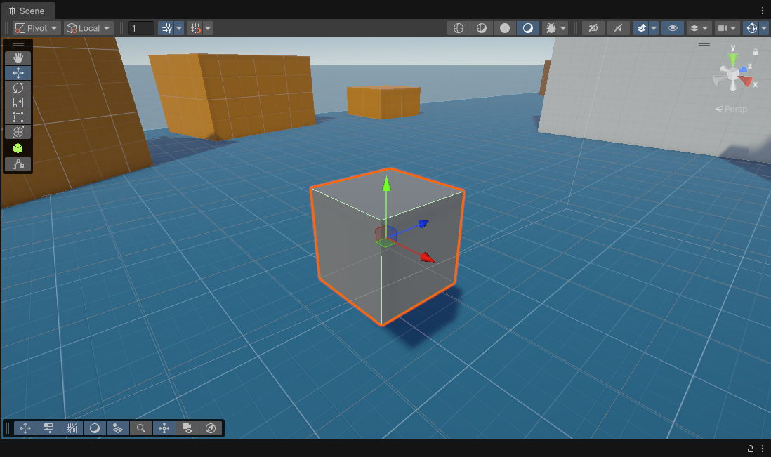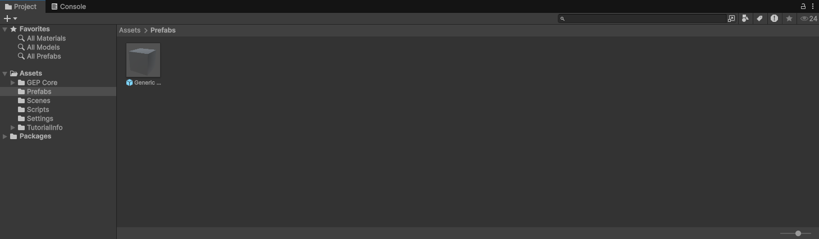
We now have a prefab object for our item. Double-click this and you will open the Prefab Editor in the Scene Window. This can be used to inspect the prefab object in isolation and make changes that will apply to all instances of the object in scene.

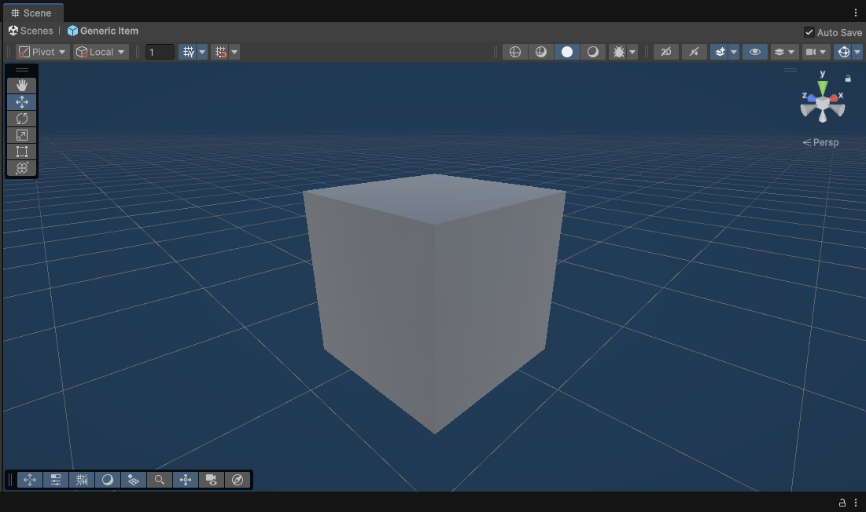
In the prefab editor, change the name of the game object to “Generic Orb” (This will change the name of the prefab asset as well). Next, in the inspector, change the value for the name in the Item component. Then change the Mesh property in the Mesh Filter component to the sphere primitive. Finally, add a Sphere Collider component and remove the already existing Box Collider component. Once you’ve done this exit out of the prefab editor by clicking the backwards arrow at the top of the hierarchy. This should take you back to the GEP core scene.
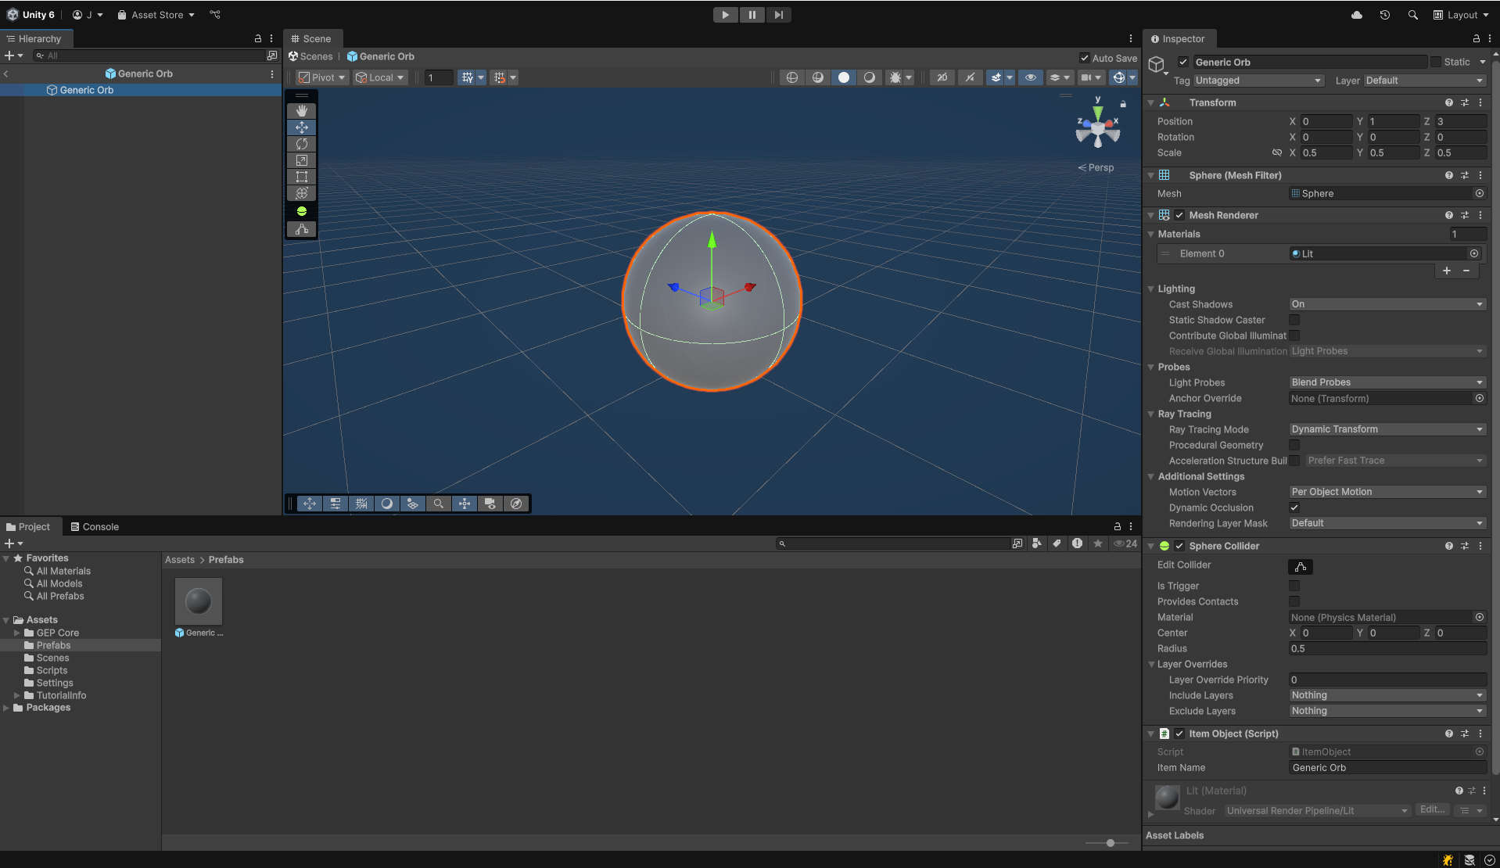
If you look at your item object in the scene now, you should see that it has changed accordingly with what we have done in the prefab editor! This is because any changes applied to the prefab asset will also extend to any existing objects in all scenes in our project. This allows for rapid modification of assets and objects where a content designer would otherwise have to keep track of every object instance of any given game object type in order to tweak their collective properties.
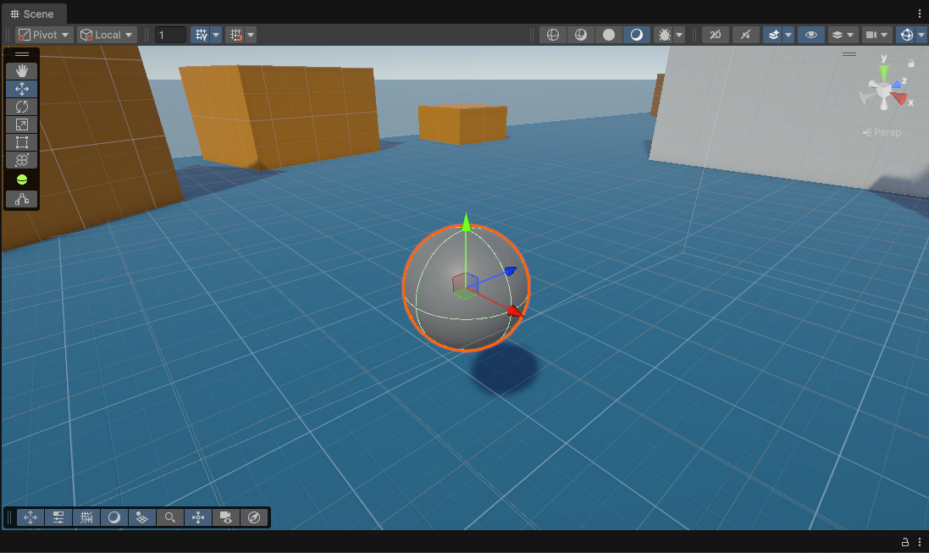

Creating Item Prefab Instances
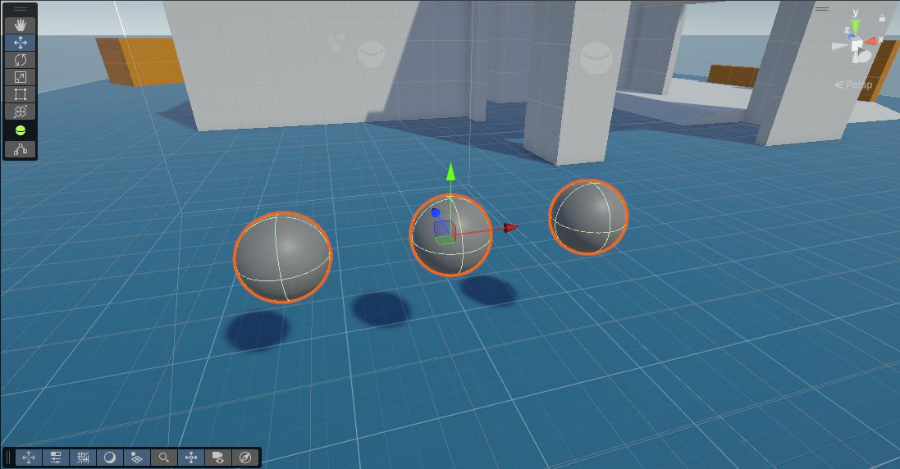
Now, drag the prefab asset into the hierarchy as a child of the object holding your items, and then do so once more. Move these new orb objects next to the already existing one. We will now make these objects unique from one another in the inspector, while retaining their prefab properties. Select the first orb in the inspector, change the value of the Material in the Mesh Renderer component to “Blue_Mat”, then change the value of the Item Name in the Item Component to “Blue Orb”. Repeat this process for the second item with “Black” and “Black Orb”, and for the third item with “Gold” and “Gold Orb”.
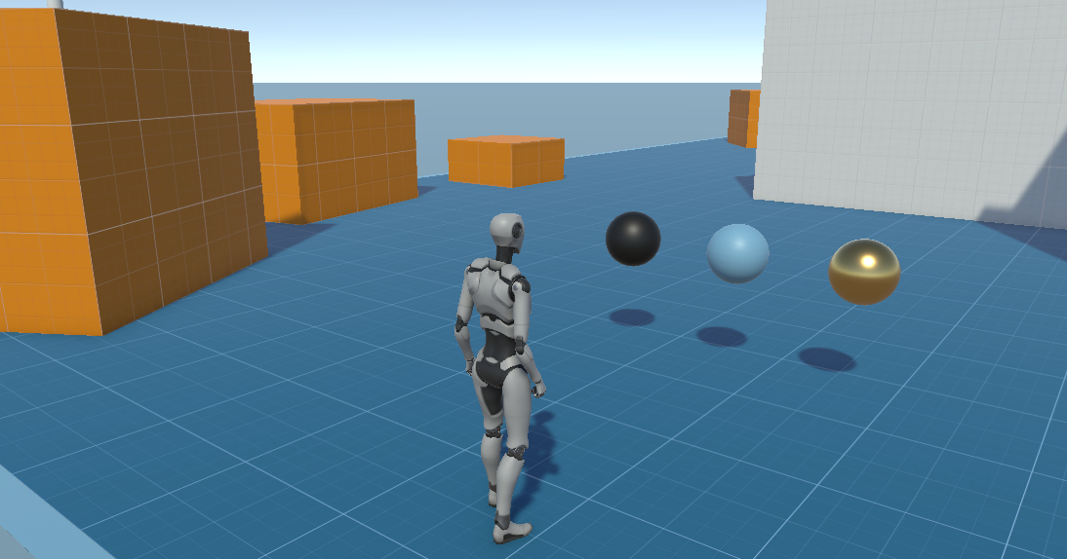
With this done, have a play in the scene with the items you have implemented. If you view the inventory component attached to the player armature object, you should see that each item is now adding its own unique string to the list of items we implemented previously. Feel free to modify these prefab object instances further, or to create new prefab assets for different kinds of objects. Additionally, if you want to reset the changes made to a prefab instance back to that of the prefab asset, this can be done from the inspector.
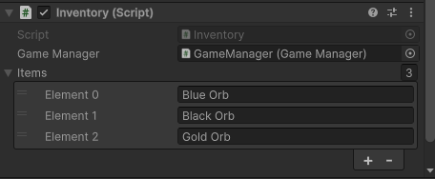

Extension Tasks
Once you have successfully completed the work outlined above, consider the following ways in which you may want to extend your project to further its quality, your understanding and your programming skills:
- The kinds of unique items we can include in our system is limited by the 3D primitives Unity has in-built. Consider sourcing additional asset packs from the Unity Asset Store / elsewhere for your items to add move variety while distinguish them from one another (Be careful of GitHub file size limits and push asset packs one at a time!).
- If you have already used inheritance to create various kinds of items from the previous worksheet’s extension tasks, consider now creating prefab assets for each item kind you have implemented, and then scatter them across the scene.
- Unity’s prefab objects are one kind of data asset the engine uses. Another would be scriptable objects, a data-driven feature that allows you to store the structure and values of a class (including behaviours) as a reusable asset instead of a game object component. Consider how you might be able to use scriptable objects to make your system more data-driven and reusable (Consider also looking into the Type Object pattern for more guidance).

